**IMAGE CAPTURING USING BLINK DETECTION**

Submitted in partial fulfillment of the requirements

of the degree of

**B. E. Computer Engineering**

By

**Aunsh Chaudhari 60004120009**

**Kena Kothari 60004120052**

**Keval Lakhani 60004120056**

Guide(s):

**Prof. Harish Narula**

Asst. Professor

|  |  |  |
| --- | --- | --- |
| D:\Admission\Admissions_1011\wwwroot\hdrlogo.gif | Department of Computer Engineering  D.J. Sanghvi College of Engineering  Mumbai– 400 056 | E:\new logo.JPG |

University of Mumbai

2015-2016

i

**CERTIFICATE**

This is to certify that the project entitled **“Image Capturing using Blink Detection”** is a bonafide work of **Aunsh Chaudhari (60004120009)** submitted to the University of Mumbai in partial fulfillment of the requirement for the award of the degree of B.E. in Computer Engineering

**(Name and sign)**

**Internal Guide**

**(Name and sign) (Name and sign)**

**Head of Department Principal**

ii

**Project Report Approval for B.E.**

This project report entitled ***Image Capturing using Blink Detection*** by ***Aunsh Chaudhari*** is approved for the degree of ***B.E. in Computer Engineering.***

Examiners

1.---------------------------------------------

2.---------------------------------------------

Date:

Place:

**iii**

Declaration

I declare that this written submission represents our ideas in our own words and where others' ideas or words have been included, we have adequately cited and referenced the original sources. I also declare that we have adhered to all principles of academic honesty and integrity and have not misrepresented or fabricated or falsified any idea/data/fact/source in our submission. I understand that any violation of the above will be cause for disciplinary action by the Institute and can also evoke penal action from the sources which have thus not been properly cited or from whom proper permission has not been taken when needed.

-------------------------------

(Signature)

-------------------------------

(Name and Roll No.)

Date:

iv

**Abstract**

This report introduces the project by providing the problem statement at hand, the desired solution and scope of the implementation involved. A review of the related work has been performed where the papers and other sources of information are mentioned. Each work of literature has contributed to an enhanced understanding of the challenges and requirements of the project at hand. Delving in the domain of the Embedded Systems, “Image Capturing using Blink Detection” can be carried out using various techniques such as Infrared Detection, Image Processing and the Electrooculogram (BCI) method. Having chosen the IR procedure to detect blinks, we proceed to process the signal and trigger the event of image capture. The project report provides the functional and non-functional requirements and presents use case diagrams to support the same. It proceeds to give a detailed step-by-step analysis of the tasks at hand through analysis and design modeling. Illustrations such as the class and activity diagrams highlight the several components involved and the workflow from start to end. The functional model is also displayed which is the behavioral or operational structure of the planned system. It exhibits all the functionalities of the device. The timeline chart is a sequential representation of the components used and processes implemented. It provides an outline of the procedural workflow of the project. Moving forward, the design gives us a picture of how the project will look as a complete functional device through prototyping such as architectural and user interface design. The working of the project puts light on the processes and exact sequence of events followed. The algorithms instrumental in performing blink detection, differentiating between false positives and negatives, accurate processing of the signal and transfer of the image through the Bluetooth module have also been mentioned and elaborated upon. Testing covers all the possible test cases showcasing sets of test data, preconditions, expected results and post conditions for each test scenario. This ensures the correct execution of each task in compliance with a particular requirement laid out at the start through requirement analysis. In conclusion, the report puts forward the various components selected, the steps that will be followed and the possible results of the application of each task executed. The future scope of the project has also been discussed. Disabled people often are not able to enjoy life’s joys to the fullest. This project will help in aiding the disabled, providing a tool for them so that they can capture the world through their eyes.

v

**Contents**

|  |  |  |
| --- | --- | --- |
| **Chapter** | **Contents** | **Page No.** |
| **1** | **INTRODUCTION** | **1-3** |
|  | **1.1 Description** | **1** |
|  | **1.2 Problem Formulation** | **1** |
|  | **1.3 Motivation** | **2** |
|  | **1.4 Proposed Solution** | **2** |
|  | **1.5 Scope of the project** | **2** |
| **2** | **REVIEW OF LITERATURE** | **4-5** |
| **3** | **SYSTEM ANALYSIS** | **6-9** |
|  | **3.1 Functional Requirements** | **6** |
|  | **3.2 Non Functional Requirements** | **6** |
|  | **3.3 Specific Requirements** | **6** |
|  | **3.4 Use-Case Diagrams and description** | **7** |
| **4** | **ANALYSIS MODELING** | **10-14** |
|  | **4.1 Activity Diagram** | **10** |
|  | **4.2 Functional Modeling** | **11** |
|  | **4.3 TimeLine Chart** | **13** |
| **5** | **DESIGN** | **15-16** |
|  | **5.1 Architectural Design** | **15** |
| **6** | **PROPOSED SYSTEM** | **17-20** |
| **7** | **TESTING** | **21** |
|  | **7.1 Possible test cases** | **21** |
| **8** | **RESULTS AND DISCUSSION** |  |
| **9** | **CONCLUSIONS & FUTURE SCOPE** | **22** |

**REFERENCES**

**ACKNOWLEGEMENTS**

v

**List of Figures**

|  |  |  |
| --- | --- | --- |
| **Fig. No.** | **Figure Caption** | **Page No.** |
| Figure 3.1 | Use Case Diagram | 9 |
| Figure 4.1 | Activity Diagram | 10 |
| Figure 4.3.1. | Data Flow Diagram- Level ‘0’ | 11 |
| Figure 4.3.2. | Data Flow Diagram- Level ‘1’ | 11 |
| Figure 4.3.3. | Data Flow Diagram- Level ‘2’ | 12 |
| Figure 4.4 | Timeline Chart | 13 |
| Figure 5.1 | System Architecture | 15 |
| Figure 6.1 | IR blink detection circuit | 18 |
| Figure 6.2 | Bluetooth module | 20 |
| Figure 6.3 | System workflow | 20 |

vii

# Introduction

## 1.1 Description

Inspired by 'The Google Glass', the project aims to capture an image using eye blink detection. The project is a system that comprises of the following components – a glass frame (spectacles), the eye-blink detection system, a microcontroller, a camera and a Bluetooth module attached to it. A smartphone stores the captured image.

The eye blink detection system uses the Infrared technique for detecting blinks. IR emitters and detectors are unobtrusively placed on the frame of the spectacles. Once the eye is blinked twice in a time span of few seconds, the microcontroller will detect a change in the voltage value and it registers that an image is to be captured. A condition will be set wherein the microcontroller will be able to differentiate between natural blinks and deliberate blinks. The condition can be based on any event such as 'double blinks' or 'one eyed blinks'. Once the microcontroller detects the event, it will send a signal to the camera and the camera will capture the image thereafter. The camera is also connected to a Bluetooth module that is used to establish a connection with any mobile device that will receive and store the image captured.

## 1.2 Problem Formulation

The question that is to be answered is whether a handsfree image capture is feasible in construction, implementation and accurate functioning?

Inspired by 'The Google Glass', the project involves a 'sunglass type looking' system which subsumes a microcontroller, a camera and a Bluetooth module attached to it. This system will be used for capturing images using the Eye Blink Detection system.

This system comprises of IR sensors which will trigger an event as and when it detects blinks in the user’s eye. The information from the IR sensors will be continuously passed on to the microcontroller which will accept the data and act accordingly. A condition will be set wherein the microcontroller will be able to differentiate between natural blinks and deliberate blinks. The condition can be based on any event such as 'double blinks' or 'one eyed blinks'. Once the microcontroller detects the event, it will send a signal to the camera and the camera will capture the image thereafter. The camera is also connected to a Bluetooth module which is used to establish a connection with any mobile device that will receive the image captured.

Another way of implementation of this project will involve usage of Voice Detection System and triggering an event based on the same. The procedure is the same but instead of the IR sensors that are used to detect blinks in the user’s eyes, the audio will be detected by a voice detection system and then the event will be triggered.

It can be useful for people who have physical constraints and are not able to access their mobile camera.

**1.3 Motivation**

Inspired by the ‘Google Glass’, we are implementing a project, which can capture images just by detecting eye blinks of the user. Google Glass gives this functionality using a different technique. Google Glass is a type of [technology](https://en.wikipedia.org/wiki/Technology) with an [optical head-mounted display](https://en.wikipedia.org/wiki/Optical_head-mounted_display) (OHMD). It was developed with the mission of producing a small-market [ubiquitous computer](https://en.wikipedia.org/wiki/Ubiquitous_computing). Google Glass displays information in a [smartphone](https://en.wikipedia.org/wiki/Smartphone)-like hands-free format.

We believe our project will prove to be useful to various sections of the society. It will be useful for individuals with disabilities so that they can enjoy clicking pictures and store their memories without using their hands. Voluntary blink is something every individual can do. Blinking will simply trigger the event and capture the image to transfer it to the smartphone via Bluetooth. It will also be useful for detectives and spies who will be able to execute their missions effectively and in a better way.

**1.4 Problem Solution**

The aim of this project to provide a hands-free and user-friendly image capturing experience. Using IR technique, blinks can be accurately registered and the event of clicking a photograph is triggered. With the help of the device proposed, photographs can be clicked at the user’s will without any manual or external assistance.

The solution to the problem statement lies in the successful construction and implementation of a device that comprises of - spectacles upholding infrared equipment (sensor and detector) and a camera. The system further consists of a microcontroller to detect a change in the signal and a Bluetooth module that successfully transfers the captured image to a smartphone.

**1.5 Scope of the project**

The goals to be achieved, tasks to be completed and deadlines to be met form the base for the scope of the project. It consists of the construction and implementation of a device that captures images with the help of eye-blink detection. Mounted on spectacles, the IR system has been chosen over the Image Processing method and Electrooculogram method for blink detection. The project looks to provide a hands-free and accurate technique for clicking photographs. With a blink of the eye, the photograph of a desired subject in front of your eyes will be stored in your smartphone.

**1.5.1 Goals**

1) to build a robust, efficient image capturing device

2) to ensure an unobtrusive, harmless and accurate technique for eye blink detection 3) hands-free, simple operation

4) real time image capture with minimum delay

**1.5.2 Tasks**

1) Eye-blink detection mechanism (IR sensor and detector) mounted on spectacles

2) Integrate microcontroller and Bluetooth module with spectacles

3) Establish Bluetooth connection between the module and the smartphone

**1.5.3 Deadline**

* March, 2015

Thus the scope of this project involves using one of the various techniques that we have studied, a signal is continuously passed to the microcontroller which analyses the signals and detects a blink. It occurs when the microcontroller senses a considerable change in the voltage value of the signal. The microcontroller then triggers an event which subsumes the sending of a signal to the camera. The camera now captures an image and sends it to a wireless bluetooth module, which is responsible for sending this image to the smartphone. Through this project, we look to aid the disabled & provide spying devices for detectives.

1. **Review of Literature**

This device has 3 main functions to execute so that the device can be considered as a working and accurate one. First function is that it has to detect an eye blink. There are various techniques of detecting eye blinks namely Detecting eye blinks using Infrared, Detecting eye blinks using Electrooculogram, and Detecting eye blinks using Image Processing technique.

In the paper written by Alice Frigario, Tessa Hadlock, Elizabeth Murray, and James Heaton, a technique to detect an eye blink using Infrared is illustrated. We came to know various concepts and techniques from this paper. Using this we came to know the advantages of using Infrared technology and how to implement it in an actual project to detect eye blinks and trigger an event.

Let us understand the process again in simpler words. The beam that comes out from the IR transmitter passes just across the front of the eyes and on the other end of the rim there is an IR detector. Until IR beams are detected by the IR detector, it does not register a blink. When the user blinks i.e. brings his upper eyelids down, the IR beam is interfered by the eyelashes and/or the lid tissue and the IR detector does not detect any signal. This causes the IR detector to drop its output voltage. As a result, a blink is registered at the microcontroller under these circumstances. Thus, this is the way an IR based blink detection circuit works.

One more method which can help in registering or detecting an eye blink is using Infrared technology. Here, the components used are IR LED’s and IR detectors. These components are placed at the centre and sides of the glass frame. The peak transmission wavelength of the Infrared LED is around 880 µm, which is also the frequency of maximal sensitivity for the matching phototransistor. The LED and detector components are positioned at the nasal and temporal aspects of one’s eye, causing the infrared beam to pass horizontally across the central portion of the palpebral fissure, anterior to the corneal surface. The beam remains unbroken when the eye is open, but is interrupted by the eyelashes and/or lid tissue when the upper lid descends, and a drop in output voltage is caused in the IR detector signal. The microcontroller is continuously in contact with the IR detector.

To understand the working of detection of an eye blink using electrooculogram, let us first gain knowledge about the method used to capture the signals. Electrodes serve as an ideal equipment to measure the smallest of electrical activities. Four electrodes are placed on the upper, lower, left and right side of each eye. The reference electrode is placed at mastoid and the ground electrode is placed at frontal lobe. The vertical and horizontal signal are calculated by subtracting lower part signal from upper part signal and non-dominant signal from dominant signal respectively.

For detecting voluntary eye blinks which can trigger the system, we can set a threshold value for the Amplitude axis in the Vertical EOG so that whenever the electric signal’s amplitude goes beyond the threshold value, the system considers it as a voluntary blink and it triggers an event. In this way, the eye-blink detection mechanism is implemented using an Electrooculogram.

Though the mechanism seems reliable, there are many disadvantages of this system as well. First, there are times when the event is triggered involuntarily since the sensors sometimes pick up faulty signals. Second, the entire equipment of Electrooculogram is obtrusive and is not user-friendly, hence leaving no space for other components in the setup. Third, the required equipment components are very costly and cannot be replaced easily. Hence, this method is not a completely efficient method for eye-blink detection.

Also, the paper written by Aree A. Mohammed and Shereen A. Anwer illustrated concepts of Image Processing. We understood various methods of implementing Image Processing technique to detect an eye blink. Even this method has its own advantages and disadvantages. The first step in this process is the intialization where a video of the individual’s face is taken and correspondingly, a process Frame method is used to create frames from this captured video. The resultant colored frames are converted to gray scale by eliminating the component of luminance. Next, for face detection we use the Haar classifier that detects an object on the basis of a facial feature. The feature is detected if the classifier is regionalizing a particular area that has the highest probability of containing the sensed feature. Moving forward, the classifier detects the face and marks it with a colored rectangle that is later useful to approximate an axis for eye detection. The detection of the eyes involves training the Haar classifiers. Once the face is detected, the AdaBoost and Haar feature algorithms train the classifier with the help of two sets of images. The first one contains the image scene, whereas the second does not contain the object at all. Consequently, having trained the Cascade classifer, the eyes are detected along the axis of the face recognition rectangle and another colored rectangle is formed bordering the eyes, showing that the eyes have been detected successfully.

Eye tracking relates to extracting features, parts of the eye in order to determine their movement. The two parts that are most important in this method are – the corneal reflection and pupil-center. With the backing of an accurate location of these features and the mathematical trignometric calculations involved, the point of regard for a pair of eyes can be found. The data obtained at the end of this procedure must be used in a sensible way because eye movements can either be voluntary or involuntary and experimental results must be evaluated accordingly. Finally, coming to the crux of the matter at hand, eye blink detection is performed using the frames that have been detected earlier. With the help of these frames, the status of the eye can be determined – whether it is open or closed.

Applying binarization to frames, thresholding is performed. In binary frames, 0 represents the black color and 1 represents the white color for each pixel. To check if the eye is blinking, the length and width of the portion below the eyebrows is determined. Keeping a count on the number of gray and black points, if the number black points detected are greater than a predetermined number, the eye is closed else it is open. The eye blink detection mechanism in this technique is subject to lighting conditions as well as the distance between the detector and the eye. If the distance is long, the process of recognition is extremely difficult. The accuracy differs depending on the lighting of the environment – natural or artificial. A significant takeaway from the IP technique is that the detection efficiency can be improved by applying the Medium Blur Filter on the binary frames. The filter aids in noise detection that is a typical pre-processing method to improve accuracy of blink detection.

**3. System Analysis**

In this chapter, we shall discuss what is expected from our system. It is categorized as functional and non – functional requirements. This chapter also specifies the minimum hardware and software need to implement the specified requirements. Later, functional requirements are described as use case diagram.

* 1. **Functional Requirements**

A functional requirement defines a function of a [system](http://en.wikipedia.org/wiki/System) or its component. A function is described as a set of inputs, the behaviour, and outputs. Functional requirements may be calculations, technical details, data manipulation and processing and other specific functionality that define what a system is supposed to accomplish. The functional requirements are captured in [use cases](http://en.wikipedia.org/wiki/Use_case). Generally, functional requirements are expressed in the form "system must do <requirement>". Few important factors in our project are:

* The device should distinguish between two different blinks and a double blink.
* The double blink should be recorded by the device.
* The camera should click a picture when it receives a signal.
* The picture should be sent to the smart-phone immediately.
* The picture should be saved in the gallery.

**3.1.1. Criticality:**

In the given software product, the functionality plays a very important role. It tells us how the system reacts to a set of inputs. The criticality of these functions tells us the performance and success of the device. The product should be tested under heavy load and stress conditions. Under these conditions the functionality of the software should not hinder. Moreover, the failure of functionality will result in failure of the entire device. Thus the product should be such that it works efficiently under different load conditions and give similar results irrespective of the stress.

**3.1.2. Technical Issues:**

Major threat to the project that is possible is that the system might get crashed or maybe a virus would cause a major problem. But, for these problems backup should be taken so that we do not lose the important data as well as we keep a continuous check onto the virus that try to affect the project and the device and eliminate by using an antivirus software preinstalled. There are chances that technical snags like non functioning of IR system or camera arise.

**3.1.3. Cost and Schedule:**

As far as the cost of the project is concerned it has been very cost efficient. This includes all the costs of hardware, software and communication. General estimation of the cost is done based on the size of our software.

**3.1.4. Risk:**

The various risks like management and the budget risks should be taken care of by the policies that are imposed on the project. Also, we plan to have proper communication with the customer for the maintenance of the device. We are trying to make use of the proactive risk strategy to avoid risks. Also, we’ll prepare a risk management plan to avoid and fight the risks which works according to the policies planned.

**3.1.5. Dependency with other requirements:**

The basic requirement needed for the device to be in working condition is the hardware. The data can be handled using many alternatives present.

**3.2 Non-Functional Requirements**

Functional requirements are supported by [non-functional requirements](http://en.wikipedia.org/wiki/Non-Functional_Requirements) (also known as quality requirements), which impose constraints on the design or implementation. Non-functional requirements are "system shall be <requirement>. Some important factors in our project are:

* The device should be easy to use by users of all age groups and also easy to carry.
* The sunglass should be comfortable when worn.
* The device should be able to click pictures even in bright sunlight.
* The quality of the picture clicked should be good.
* The device should not be very conspicuous.
* The sensors used should not harm the eyes.
  + 1. **Reliability:**

The R.I. generation will impact the decision of normality and abnormality for a node and will also impact the packet delivery. Hence to make system reliable, the guidelines must be followed very carefully under the guidance of a field expert.

* + 1. **Maintainability:**

One thing it explains is the Application extendibility. The application should be easy to extend. The code should be written in a way that it favours implementation of new functions. The design should be in such a way that future functions could be implemented easily to the application and databases of new nodes could be loaded easily. Other thing it explains is Application testability. Test environments should be built for the application to allow testing of the applications different functions. It is used for testing the application.

* + 1. **Portability:**

It explains the Application portability. We are trying to build it in such a way that it can be used on multiple OS and in any environment without any manual use.

* + 1. **Binary Compatibility:**

Binary Compatibility means running of the software not only on one system but also on another. The application is able to run on some other host machine apart from the one on which it is made.

* + 1. **Extensibility:**

It explains how extensible is the device i.e. if you try to put new functionality or by modifying the existing one. Our software is extensible in terms of adding new database schemas and loading new data. Our system can also include new test parameters for future use.

**3.3 Specific Requirements**

* Sensors - IR sensors
* Camera - Webcam
* Microcontroller – Raspberry Pi
* Bluetooth module – Bluetooth dongle
* Smart phone - Android OS

**3.4 Use case Diagrams and descriptions**

The use case diagram consists of 3 external actors namely the user, the device, and the smart-phone. The user has to blink twice and this will be detected by the device, which will capture the scene in front of it. The image captured will be sent to the smart-phone immediately. It will then save the image in the gallery. The user can then view the image in the smart-phone.

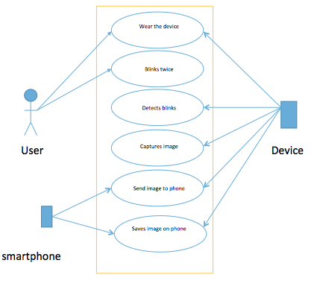

Figure 3.1 Use Case diagram

**4. Analysis Modeling**

**4.1 Activity Diagram**

This diagram describes various activities performed in software under given scenario.

**Scenario:** This is the activities taking place from the point of view of each actor.

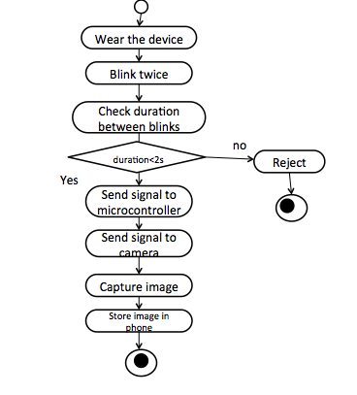

Fig 4.1 Activity Diagram

**4.2 Functional Model**

This section represents how data objects are transformed as they move through the system. flow-oriented modeling provides a view of the system that is unique—it should be used to supplement other analysis model elements

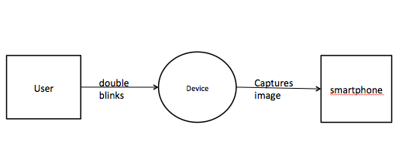

Figure 4.3.1 DFD Diagram Level 0

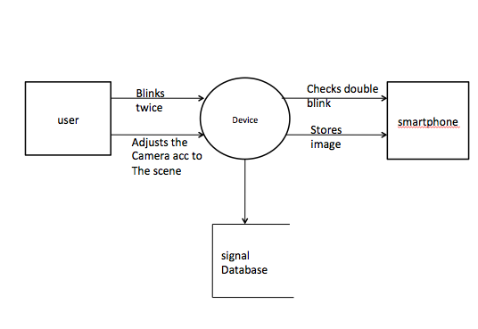

Figure 4.3.2 DFD Diagram Level 1

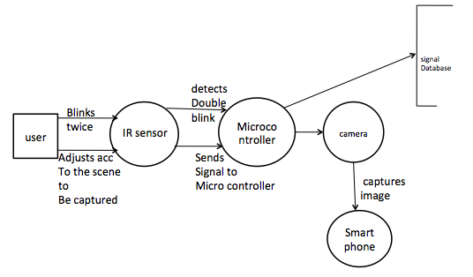

Figure 4.3.3 DFD Diagram Level 2

**4.3. Timeline chart**

The chart below depicts the expected schedule to be followed for the project.

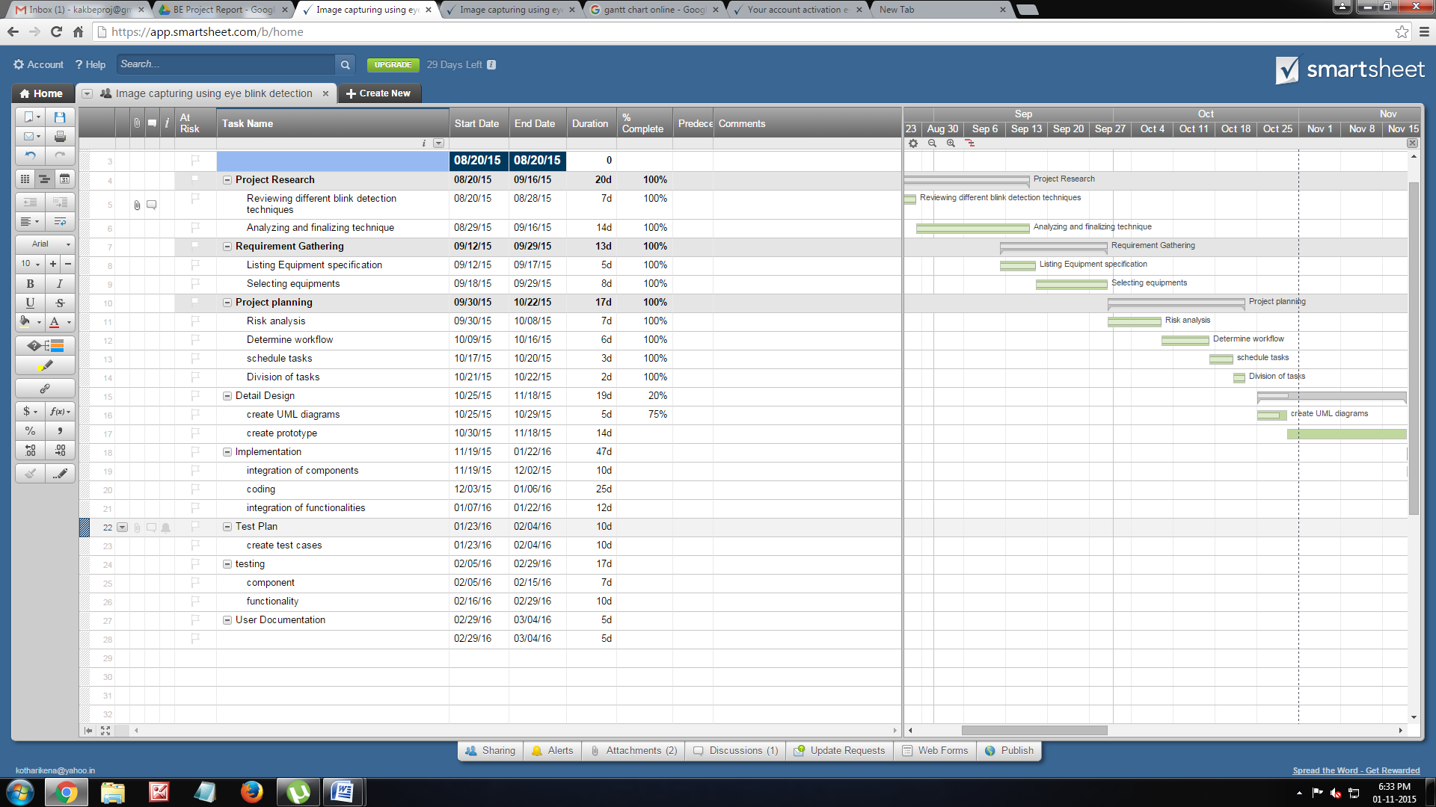



Fig 4.4 Timeline Chart

1. **Design**

In this chapter, we illustrate the architecture diagram for our proposed solution.

* 1. **Architectural Design**

**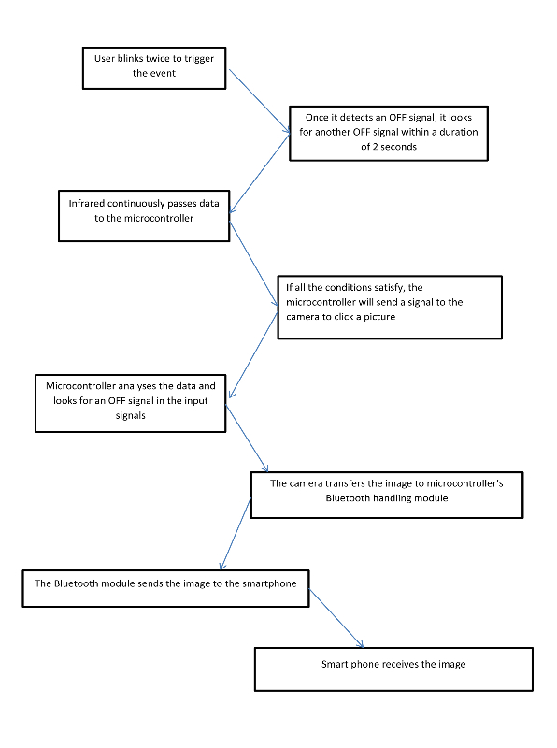**

Fig 5.1 System Architecture Design

The System Architecture consists of the following components:

1) Spectacle Frame: Holds the camera and IR detection system

2) IR blink detection system: Comprises of IR emitter and IR detector

3) Raspberry Pi microcontroller: Receives signals from IR detector and recognizes blink due to change in voltage value

4) Camera: A mini camera that is mounted on the hat to capture an image after the user blinks

5) Bluetooth connection: Using a Bluetooth dongle that is easily connected to one of the many USBs offered by the Raspberry Pi microcontroller, simple and efficient transfer of the photograph clicked is enabled

6) Smartphone: The image captured is stored in the gallery of the wirelessly Bluetooth connected smartphone

**6. Implementation**

* 1. **Method used**

After going through the disadvantages and the advantages of all the methods for detecting an eye blink to trigger an event, we choose the Infrared method of detecting the eye blink because of its advantages that far outweigh its disadvantages. The advantages of using IR for blink detection are as follows –

1. It is very user friendly and cost effective compared to other methods.
2. The final product looks very simple and nor complicated for users. Also, it is light weight.
3. This method gives greater accuracy than any other method used for blink detection.
4. It does not involve large hardware components which make the product heavier.
5. Adding to this, the method or hardware technology used to detect the eye blink should be able to pass a signal to the microcontroller easily and relinquish its control to another component, which can be easily implemented in this case.

Hence, based on these advantages, the Infrared and microcontroller based eye blink detection system seemed to be more feasible and reliable and hence, we choose this method to detect the user’s eye blink. There are some problems of using this technology as well. One of the problems, which we will face while implementing this method is to differentiate between voluntary and involuntary blinks. We successfully found out a way to differentiate between these different types of blinks so that the event is not triggered whenever the user blinks involuntarily or in simpler words, because of natural blinks. But this can be easily solved by setting a condition that if the user blinks twice in the time range of 1.2 seconds, the event will be triggered. Another condition which we can use is if the user blinks a single eye and does not blink the other one, the event will be triggered. Any of these conditions can be set and implemented. This will make the entire process more effective and less complicated, so that any user can understand the process.

* 1. **Working of the project**

**6.2.1 Eye blink detection using Infrared and Microcontroller:**

The Infrared emitter and detector are on continuously after the device is switched on by the user. The data received by the Infrared receiver is continuously supplied to the microcontroller for example Arduino. The microcontroller looks for ‘OFF’ signals among the signal inputs provided to it. These OFF signals are transmitted when the Infrared ray is obstructed and the detector does not detect any Infrared ray. When the microcontroller detects this OFF signal it starts looking for an ON signal and an OFF signal following it under a time interval of 2 seconds. If all the conditions pass, the microcontroller triggers the event and it sends a signal to the camera to capture an image and relinquishes the control to it.

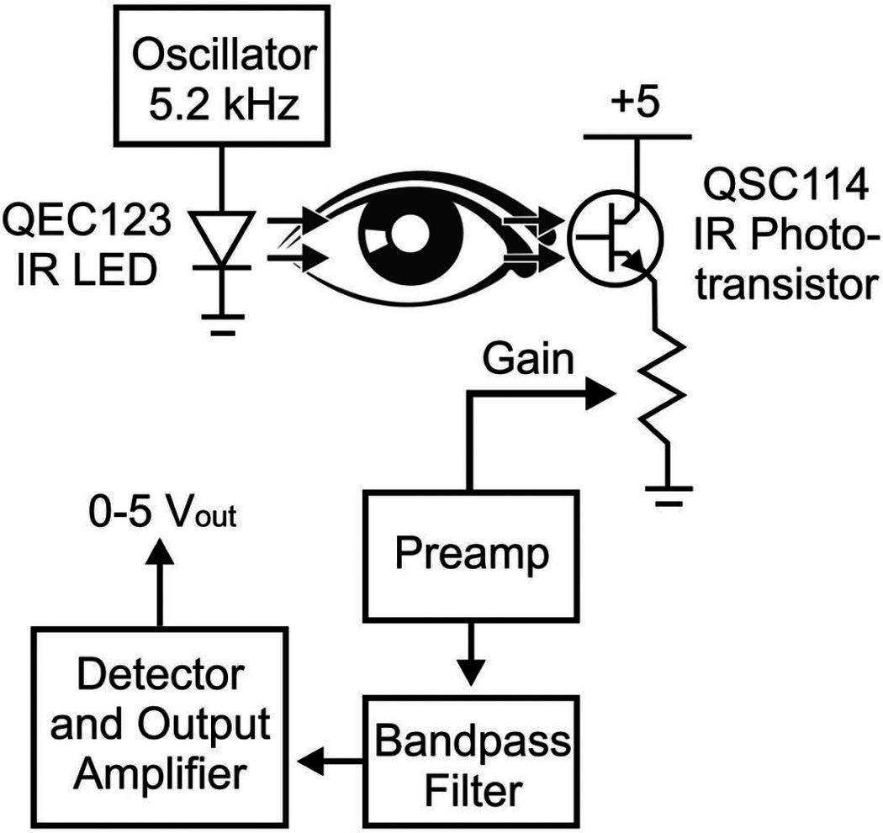

Figure 6.1 Working of IR blink detection circuit

**6.2.2 Camera:**

When the microcontroller sends a signal to the camera, the camera captures an image using its module and makes this image ready for transferring it to the smartphone via Bluetooth. The camera module is connected to the microcontroller such as Raspberry Pi to automatically control the camera. The microcontroller is connected to the camera via a diode and a shutter switch cable. When the microcontroller passes a LOW voltage signal to the camera, the camera module activates and when the microcontroller passes a HIGH voltage signal to the camera, the diode becomes reverse biased and prevents the electricity flowing into the camera to avoid damaging thee camera module. In this way, a microcontroller and a camera work. The camera which is suited for this use is a webcam, which looks like this –

**6.2.3 Bluetooth module:**

Bluetooth is a wireless technology which helps in transferring files from one device to other using radio waves. It operates at the frequency of around 2.4 GHz. The transfer of data takes places only over short distances. After the camera has captured the image it transfers the image to the Bluetooth module and makes it ready to transfer. The microcontroller then transfers the control to the Bluetooth module. The Bluetooth module has to be paired with the smartphone for transferring the images without any glitch. It then transfers the image wirelessly to the android device. The Bluetooth needs to be connected to the camera and the microcontroller at the same time. The Bluetooth module when connected to the Raspberry Pi board, in this case, looks as –

In this way, these components function to give optimum results for the application. This application will help the disabled and paralyzed people to be able to gain the joys of life. They will be able to capture the world through a camera without restraining due to any of their disability.

Bluetooth is a useful tool for getting devices communicating wirelessly. If you want your Raspberry Pi interacting with anything, from a printer, to a mobile phone, to setting up media streaming, bluetooth is the way to go! this guide will show you how to install it.

This guide is completed on Raspian "Wheezy", so the first step is to make sure you have the latest Raspbian "Wheezy" Operating System (OS) installed on your Raspberry Pi. You can download the latest version here: http://www.raspberrypi.org/downloads

Step for  Update and Install

1. There's a few updates we need to run to make sure that our Raspberry Pi's software packages are all spiffy before we can proceed to installing the software we need for the bluetooth dongle. Skip this step if you're happy that your Pi's packages are already OK! Make sure you have a decent internet connection on your Pi before proceeding!

We'll need to make sure we've got the latest firmware drivers by running the following commands:

sudo apt-get update

(This updates the list of available packages and their versions, but it does not install or upgrade any packages.)

sudo apt-get upgrade

(This actually installs newer versions of the packages you have. After updating the lists, the package manager knows about available updates for the software you have installed.)

sudo apt-get autoremove

(This will then remove all of the reduntant packages after the latest upgrade)

2. We're now ready to install the software we need to interact with the bluetooth dongle!

which will take approx. 30 minutes with the following command:

sudo apt-get install bluetooth bluez-utils blueman

switch your Pi off, plug the Bluetooth dongle in, and switch the Pi back on.

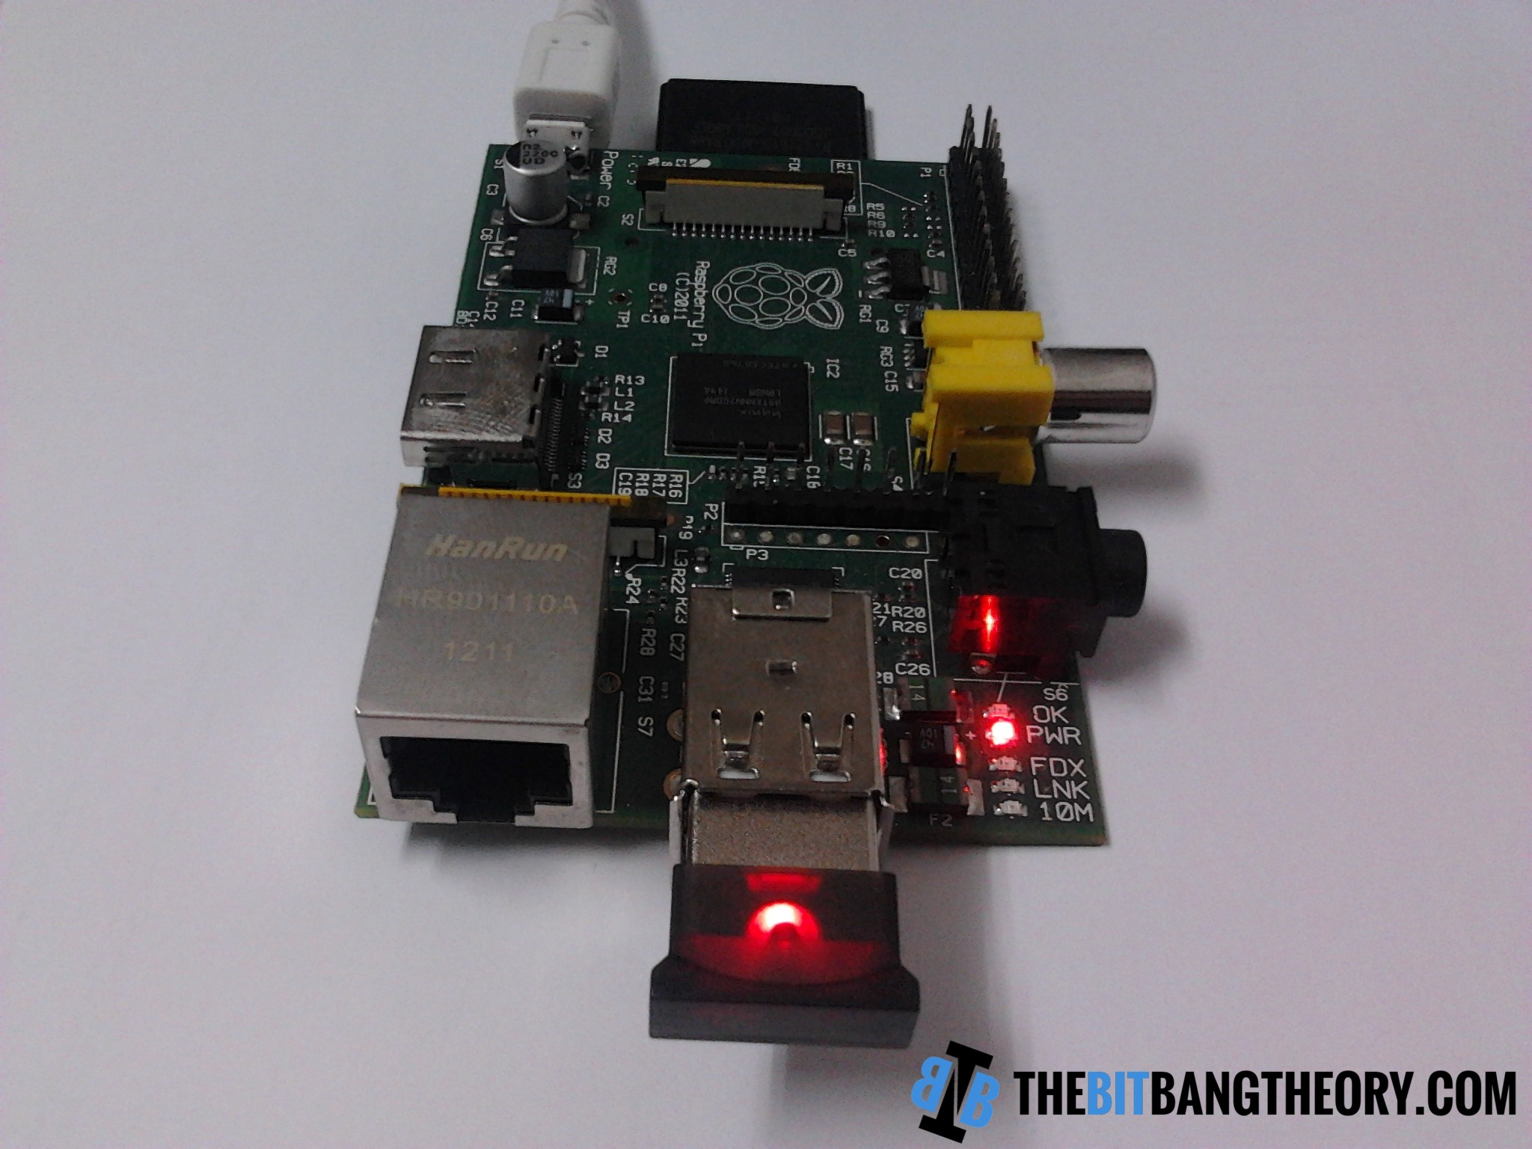

Figure 6.2 Bluetooth dongle connected to the Raspberry Pi

**6.2.4 System workflow**

Thus, we can understand the steps of entire process by referring to a block diagram:

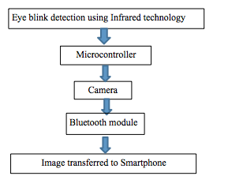

Figure 6.3 System workflow

**7. TESTING**

**7.1 Possible test cases**

Tests can be conducted in various conditions and situations:

1) Different lighting conditions

* Well lit room
* Daylight
* Night time

2) Person wearing spectacles

* Each individual has a different nose bridge
* If wearing the device over spectacles is possible

3) Facial posture and positioning of subject

* Centre, right and left tilt
* Distance from subject

4) Blink detection accuracy

* Differentiating between voluntary and involuntary blinks

5) Wavelength of IR

* Ensuring IR detection without harming the eye
* Wavelength within threshold

6) Weight of equipment and noticeability

* It should light-weighted and inconspicuous

7) Bluetooth

* Within range

8) Image capture

* Real time capture
* Storing delay

**8. RESULTS AND DISCUSSIONS**

The test cases mentioned above give the following results based on the parameters tested –

1. The device works perfectly under different lighting conditions. Under a well lit room and nightlight, the device gives accurate results. Although, considering daylight, the IR detector constantly acts as if it is receiving IR rays even when obstructed. This problem can be solved by using a small blockage against the IR emitter and receiver so that the IR acts as if it is in a dark room and gives accurate results.
2. Different people have different facial contours and hence the infrared emitter and detector might not be comfortable for some. The solution to this is that

**8. CONCLUSION AND FUTURE SCOPE**

Image capturing using blink detection is an exciting, demanding yet feasible project. There are various ways this project can be implemented and each technique involves a number of components functioning inside it. As a result of a thorough understanding of three methods and their benefits as well as flaws, we felt the most suitable way is the one using Infrared LED’s to detect the eye blinks. This project has a lot of scope in the future as it can be improved upon and implemented to perform what technology does best – make life easy.

The future scope of this project is:

1) The triggering event can be set as the user wants it. For instance – If a user wants to trigger image capture when he blinks his left eye twice, he should be able to set it.

2) This device can be used as spying equipment, which can help spies, detectives and officials capture certain images secretly without losing focus of their target.

3) Cops can use this device to scan people on the go and prevent harmful attacks by people carrying harmful weapons illegally. For this purpose, the glasses in the device can be converted to a LCD screen and Image Processing techniques can be used to detect any substance they want to.

4) It can also be used for video recording purposes by students, professors and many other sections of the society.

5) Voice driven Image capturing using Natural Language Processing

**REFERENCES**

[1] Aree A. Mohammed and Shereen A. Anwer “Efficient Eye Blink Detection Method for disabled-helping domain” International Journal of Advanced Computer Science and Applications

[2] Masaki Nakanishi, Yasue Mitsukura , Yijun Wang, Yu-Te Wang

“Online voluntary eye blink detection using Electrooculogram, 2012 International Symposium on Nonlinear Theory and its Applications.

[3] Alice Frigerio, Tessa A Hadlock, Elizabeth H Murray and James T Heaton “Infrared-based blink detecting glasses for facial pacing towards a bionic blink”

[4] Chinnawat Devahasdin Na Ayudhya and Thitiwan Srinark “A Method for Real-Time Eye Blink Detection and its Application”

[5] Vishal Bhandari “Eye Blink Detector – A Microcontroller 8051 Based

<https://cmsrlabs.wordpress.com/projects/microcontrollers/eye-blink->

detector/

[6] Murray V. Johns “Assessing drowsiness of drivers” Commissioned by Vic Roads, Australia

[7] Dr.Suryaprasad J, Sandesh D, Saraswathi V, Swathi D, Manjunath S “Real Time Drowsy Driver Detection Using Haarcascade Samples vol 3 DOI : 10.5121/csit.2013.3805 Computer Science Institute and Technology

[8] Ye Sun “An Innovative Non-Intrusive Driver Assistance System for Vital SignalMonitoring” IEEE Journal of Biomedical and Health Informatics, 2013

**ACKNOWLEDGEMENTS**

I would like to express our sincere gratitude to our guide Prof. Harish Narula for his guidance, encouragement and gracious support throughout the course of our work, for his expertise in the field that motivated us to work in this area and for his faith in us in every stage of this research.

We’re grateful to Dr. Narendra Shekokar, Head of the Computer Engineering Department, for letting us use the department resources, labs and books.

I am highly indebted to our Principal, Dr. Hari Vasudevan for availing us with library books and relevant materials and also the SVKM management for providing us with popular and resourceful journals like IEEE and other online material that helped us finish our project with ease and perfection.

I would also like to thank all our fellow students and staff of Department of Computer Engineering for their help in the whole process leading to the conceptualization of the project.

Aunsh Chaudhari